Following Jesus
Reading: Luke 5:4-11
When he finished speaking, he turned to Simon. Jesus said, “Go out into deep water. Let down the nets so you can catch some fish.
Simon answered, “Master, we’ve worked hard all night and haven’t caught anything. But because you say so, I will let down the nets.”
When they had done so, they caught a large number of fish. There were so many that their nets began to break. So they motioned to their partners in the other boat to come and help them. They came and filled both boats so full that they began to sink.
When Simon Peter saw this, he fell at Jesus’ knees. “Go away from me, Lord!” he said. “I am a sinful man!” He and everyone with him were amazed at the number of fish they had caught. So were James and John, the sons of Zebedee, who worked with Simon.
Then Jesus said to Simon, “Don’t be afraid. From now on you will fish for people.” So they pulled their boats up on shore. Then they left everything and followed him.
Thought about the reading
In this series of Bible readings, we will be learning about Peter (sometimes called Simon). He was one of the special friends of Jesus. In the story today, we hear how Jesus called him to follow him.
Being a Christian is not just about doing good things. Jesus calls us to follow him, just like he called Peter. When we follow Jesus, we try to do what Jesus wants us to do.
Jesus told Peter that he would ‘fish for men.’ That means that Peter was to tell others about him. That is now our job too. If we have chosen to follow Jesus, he wants us to tell other people that Jesus loves them and invites them to become his followers. We do that by the way we live, as well as what we say. It may not always be easy, but Jesus will help us.

Prayer

Lord Jesus, I love you. Thank you for forgiving me. Please help me to show your love to other people so that they will want to follow you too.
Amen

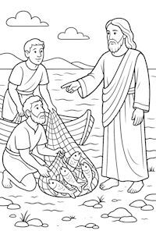

Cambridge Causeway

Spring 2026
Bible Study notes

Living for Jesus
- Following Jesus
Based on the teaching plan published by Count Everyone In.

