Noah
Reading: Genesis 6:9, 17-22
This is the history of Noah’s family. He was a good man all his life, and he always followed God.
God said to Noah, “I will bring a great flood of water on the earth. I will destroy all living things that live under the heaven. Everything on the earth will die. I will make a special agreement with you. You, your wife, your sons, and their wives will all go into the boat. Also, you will take two of every living thing on the earth with you into the boat. Take a male and female of every kind of animal so that they might survive with you. Two of every kind of bird, animal, and creeping thing will come to you so that you might keep them alive. Also, bring every kind of food into the boat, for you and for the animals.
Noah did everything the Lord commanded him.

Thought about the reading
There are lots of heroes in the Bible, people who did extraordinary things for God. But they are not people with superpowers like the superheroes we see in films. The heroes in the Bible are ordinary people, who listen to God and trust him.
Noah was someone who followed God. God told him that there was going to be a great flood which would destroy all life on the earth. He told Noah to build a big boat for him and his family, and two of every kind of animal. Noah trusted God and built the boat.
Perhaps Noah’s neighbours thought he was crazy to build a big boat in the middle of the land! But when the flood came, God kept him and his family and the animals safe until the waters went down.
If we trust God like Noah did, we too can be a hero for God, even if we feel that we are very ordinary. God will keep us safe when things are difficult. He will help us do amazing things for him.

Prayer
Lord Jesus, thank you for Noah. Thank you that he listened to you, trusted you and did what you told him.
Please help me to trust you and to do what you tell me.
Amen

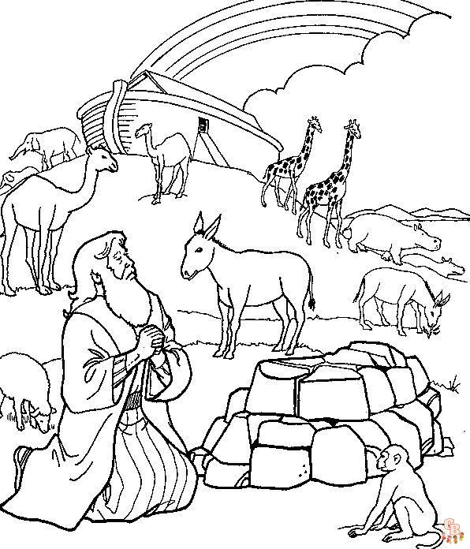

Cambridge Causeway

Spring 2024
Bible Study notes

Heroes of the Bible
- Noah

By Chrissy Cole

Trust the Lord always, because in the Lord you have a place of safety forever.
Isaiah 26:4

