Restore
Reading: Nehemiah 1:1-4
I, Nehemiah, was in the capital city of Susa. One of my brothers and some other men came from Judah. I asked them about the Jews who had escaped captivity and still lived in Judah. I asked them about the city of Jerusalem.
They answered, “Nehemiah, the Jews who escaped captivity and are in the land of Judah are in much trouble. They are having many problems and are full of shame because the wall of Jerusalem is broken down, and its gates have been burnt with fire.”
When I heard this about the people of Jerusalem and about the wall, I sat down and cried. I was very sad. I fasted and prayed to the God of Heaven for several days.
Thought about the reading
Nehemiah lived hundreds of years before Jesus was born. The people of Israel had been taken away from their homes by the Babylonians and now lived on a foreign land. Nehemiah worked for King Artaxerxes. He was the king’s cup bearer, which meant that he was in charge of the king’s wine.
Nehemiah heard from his brother that his hometown of Jerusalem, God’s special city, was in trouble. The walls were broken down and the gates burnt. It made him feel very sad. He was so sad that he cried and prayed for several days.
Nehemiah knew that the people of Israel had broken the laws that God had given them. He asked God to forgive them and to help them rebuild Jerusalem.
We can see that some things in our world are not right. We may feel that we also have done wrong. It might make us feel sad. But, just like Nehemiah, we can come to God and ask for his forgiveness.
Prayer
Lord Jesus, we are sad because we sometimes do things wrong. We are sad because we can see things that are wrong in the world around us. Please forgive us and help us to make things better.
Amen

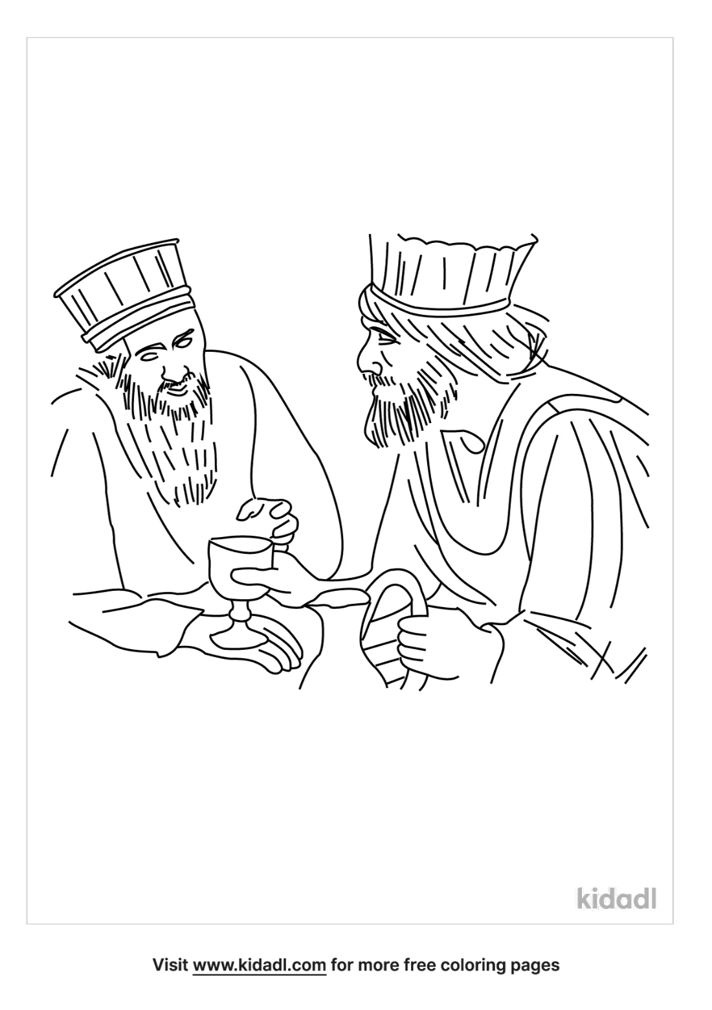

Cambridge Causeway

Autumn 2022
Bible Study notes

Nehemiah’s Story
1.Restore
By Chrissy Cole

