**Joseph**

**Reading 1:** Genesis 37:18, 21-22, 25, 28, 36

Joseph’s brothers saw him coming from far away. They decided to make a plan to kill him. But Reuben wanted to save Joseph. He said, “Let’s not kill him. We can put him into a well without hurting him.” When Joseph came to his brothers, they attacked him and tore off his long and beautiful coat. Then they threw him into an empty well that was dry.

While Joseph was in the well, the brothers sat down to eat. They looked up and saw a group of traders travelling from Gilead to Egypt. When the traders came by, the brothers took Joseph out of the well and sold him to the traders for 20 pieces of silver. The traders took him to Egypt.

The traders later sold Joseph in Egypt. They sold him to Potiphar, the captain of Pharaoh’s guards.

**Reading 2:** Genesis 45:4-8

Joseph said to his brothers, “I am your brother Joseph. I am the one you sold as a slave to Egypt. Now don’t be worried. Don’t be angry with yourselves for what you did. It was God’s plan for me to come here to save people’s lives. This terrible famine has continued for two years now and there will be five more with out planting or harvest. So God sent me here ahead of you so that I can save your people in this country.”

**Thought about the reading**

Jospeh lived a long time ago. He had ten older brothers. They hated him because his father loved him best of all. They decided to get rid of him, so they sold him to some traders, who took him to be a slave in Egypt.

Joseph must have been very frightened, but he trusted God. After many adventures, he helped the king of the Egyptians, the Pharaoh, to understand some dreams. The dreams told Pharoah that a famine was coming when no food would grow. Joseph told him to save food before it happened so that everyone would have something to eat. Pharaoh put him in charge of his kingdom and Joseph was able to help everyone when nothing would grow.

Joseph was a hero. He trusted God. He knew God was looking after him when things seemed bad. God used him to help lots of people, including his own father and brothers.

**Prayer**

Lord Jesus, thank you for Joseph. Thank you that he trusted you when things were bad.

Please help me to trust you. Please use me to help other people. Amen

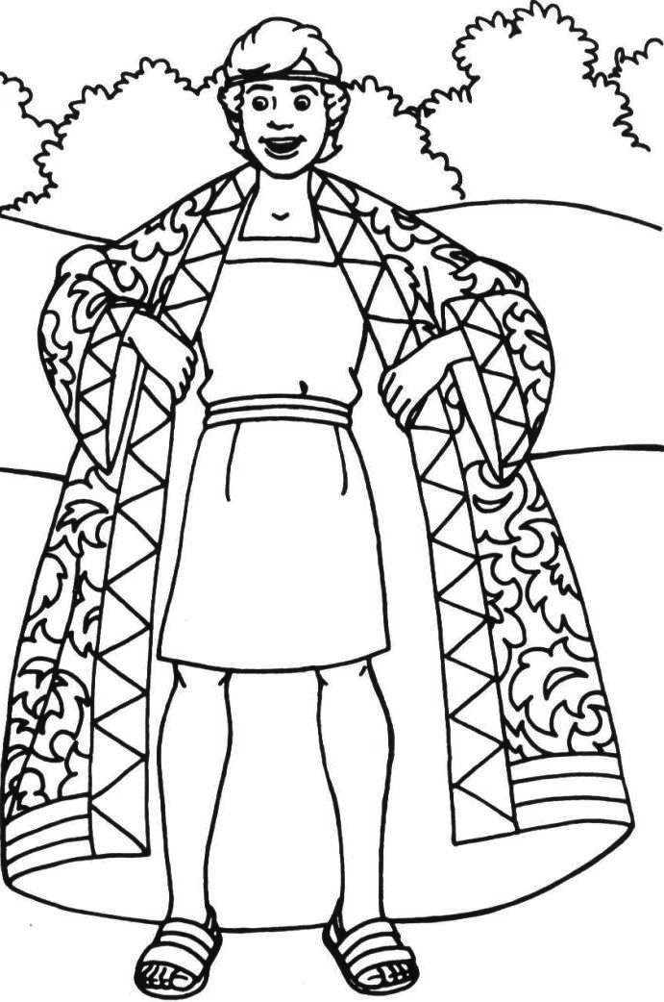

**Joseph**

**Cambridge Causeway**

Spring 2024

Bible Study notes

**Heroes of the Bible**

**2. Joseph**

By Chrissy Cole

Trust the Lord always, because in the Lord you have a place of safety forever.

Isaiah 26:4