Copying Jesus
Reading: Matthew 14:22-33
Right away Jesus made the disciples get into the boat. He had them go on ahead of him to the other side of the Sea of Galilee. Then he sent the crowd away. After he had sent them away, he went up on a mountainside by himself to pray. Later that night, he was there alone. The boat was already a long way from land. It was being pounded by the waves because the wind was blowing against it.
Shortly before dawn, Jesus went out to the disciples. He walked on the lake. They saw him walking on the lake and were terrified. “It’s a ghost!” they said. And they cried out in fear.
Right away Jesus called out to them, “Be brave! It is I. Don’t be afraid.”
“Lord, is it you?” Peter asked. “If it is, tell me to come to you on the water.”
“Come,” Jesus said.
So Peter got out of the boat. He walked on the water toward Jesus. But when Peter saw the wind, he was afraid. He began to sink. He cried out, “Lord! Save me!”
Right away Jesus reached out his hand and caught him. “Your faith is so small!” he said. “Why did you doubt me?”
When they climbed into the boat, the wind died down. Then those in the boat worshiped Jesus. They said, “You really are the Son of God!”
Thought about the reading
When we decide to follow Jesus, we want to become like him. We want to do the things he does. We want to copy him. In the story today, Peter wanted to copy Jesus. Jesus was walking on the water in the middle of a storm! It was a miracle! Peter wanted to do the same. He got out of the boat, and he did walk on the water. But when he saw the wind and waves, he started to sink.
Sometimes it is easy to copy Jesus. We can pray like Jesus did. We can help our friends like Jesus did. Sometimes it is harder to copy him, like when Peter walked on the water. Jesus probably won’t ask us to walk on water, but he might ask us to talk to someone new, or move house, or start a new job. Other people might think we are being foolish to follow him. But, just as Jesus helped Peter in the water, he is there to help us too.
Prayer
Lord Jesus, please help me to be brave and do what you ask me to do, even when it is hard. Help me to trust you.
Amen

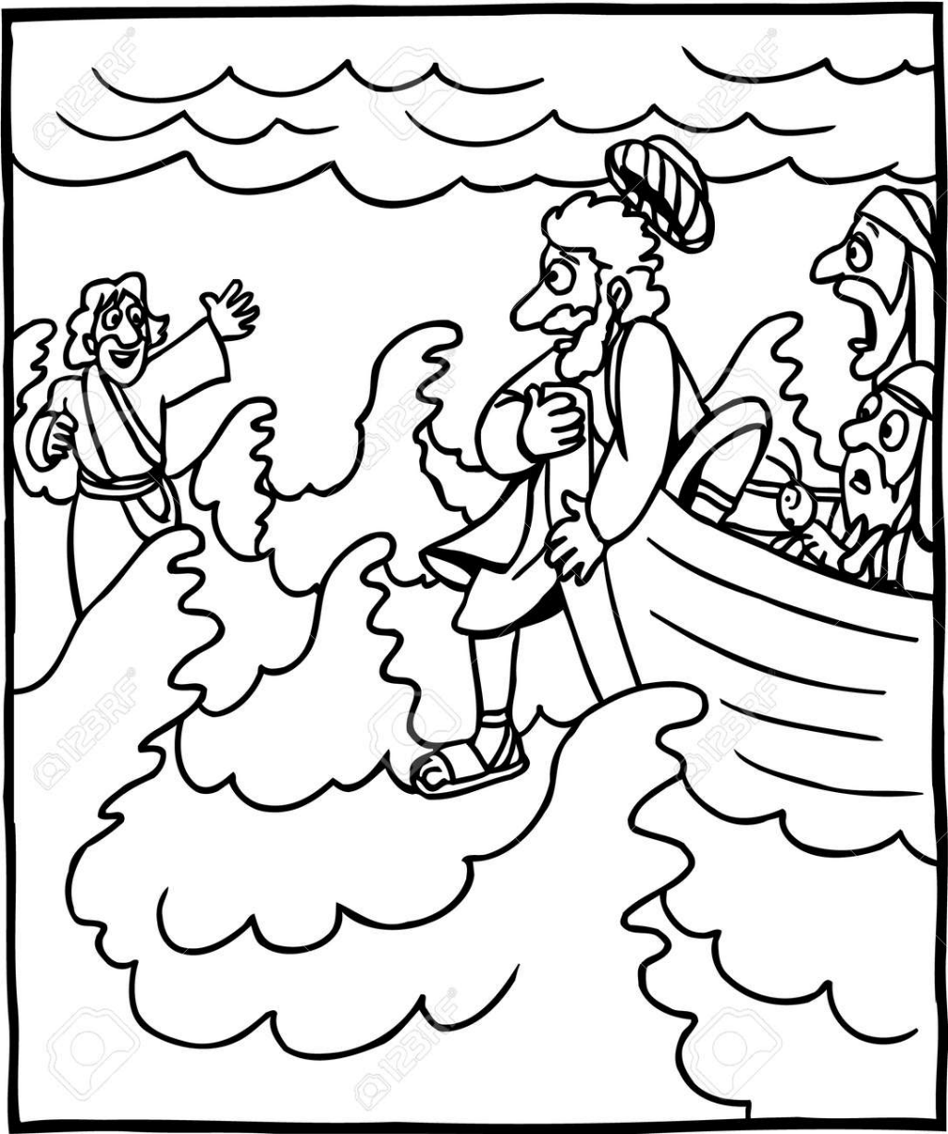

Cambridge Causeway

Spring 2026
Bible Study notes

Living for Jesus
2. Copying Jesus
Based on the teaching plan published by Count Everyone In.

