**Made in God’s Image**

**Reading:** from 1 Samuel 16:1-14

The Lord said to Samuel, “Fill your animal horn with olive oil and go on your way. I am sending you to Jesse in Bethlehem. I have chosen one of his sons to be king.”

Samuel did what the Lord said. He arrived at Bethlehem. The elders of the town met him. They asked, “Have you come in peace?”

Samuel replied, “Yes, I’ve come in peace. I’ve come to offer a sacrifice to the Lord. Set yourselves apart to him and come to the sacrifice with me.” Then he set Jesse and his sons apart to the Lord. He invited them to the sacrifice.

When they arrived, Samuel saw Eliab. He thought, “This has to be the one the Lord wants me to anoint for him.”

But the Lord said to Samuel, “Do not consider how handsome or tall he is. I have not chosen him. The Lord does not look at the things people look at. People look at the outside of a person. But the Lord looks at what is in the heart.”

Jesse had seven of his sons walk in front of Samuel. But Samuel said to him, “The Lord hasn’t chosen any of them.” So he asked Jesse, “Are these the only sons you have?”

“No,” Jesse answered. “My youngest son is taking care of the sheep.”

Samuel said, “Send for him. We won’t sit down to eat until he arrives.”

So Jesse sent for his son and had him brought in. He looked very healthy. He had a fine appearance and handsome features.

Then the Lord said, “Get up and anoint him. This is the one.”

**Thought about the reading**

The story today took place hundreds of years before Jesus was born. God wanted to choose a new king for the people of Israel, so he sent his servant Samuel to Jesse’s family in Bethlehem. Samuel looked at all Jesse’s sons, but none of them was the one God wanted to be king, even though they were tall and handsome. God chose the youngest, and most unimportant son, David. God is not impressed by how we look – he sees what is in our heart.

When we watch television or read newspapers, we see people who are rich and beautiful and powerful. Everyone thinks they are amazing. If we are not like that, we might feel we are worthless and unimportant. That is not how God sees us. It doesn’t matter who you are, you are loved by God.

**Prayer**

Dear Jesus, thank you that everyone is important to you. Thank you that you don’t look at the outside, but at our hearts. Thank you that you love me. Amen

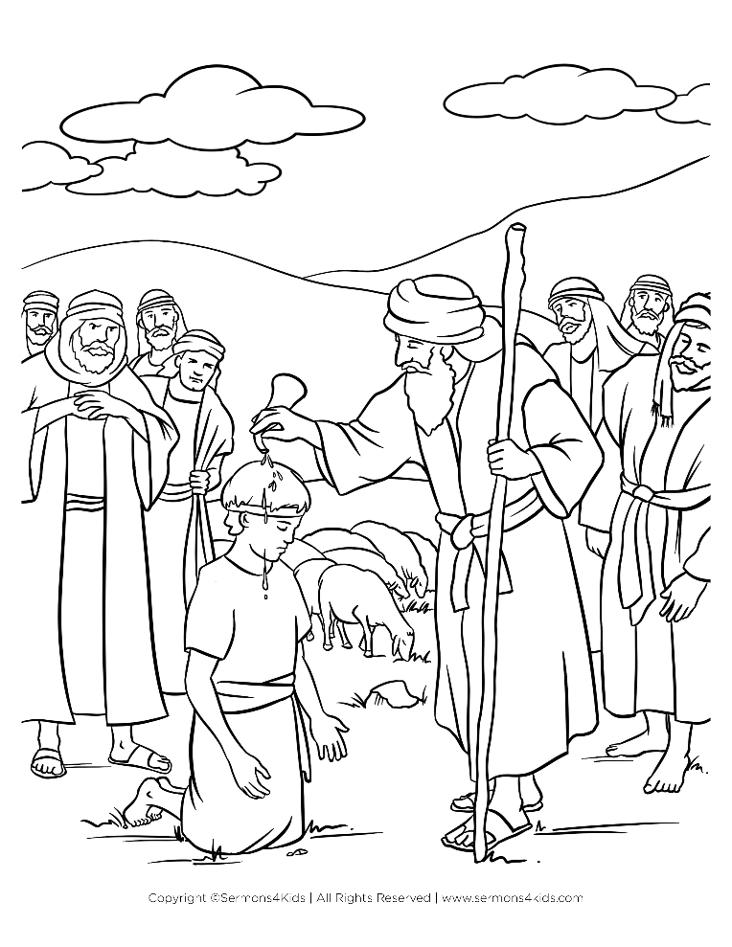

**Cambridge Causeway**

Autumn 2025

Bible Study notes

**Disability Sunday 2025**

**Made in God’s Image**

By Chrissy Cole