**Helping others**

**Reading:** Matthew 5:43-45a

Jesus said, “You have heard it said, ‘Love your neighbour and hate your enemy. But I tell you, love your enemies. Pray for those who treat you badly. If you do this, you will be children who are truly like your Father in Heaven.”

**Thought about the reading**

Who are the people you love? Maybe your family, or your friends. What about people who have hurt you, or been unkind? Jesus said that we should love everyone, even those who are unkind to us.

On a different day, he told a story to help us understand how we should love everyone. He told a story about a Jewish man who was beaten up by thieves and left on the road. No-one stopped to help him, until a Samaritan came along. Now Jews and Samaritans hated each other. They were enemies. But this Samaritan felt sorry for the Jewish man and even though they were enemies, he stopped to help. He put bandages on his cuts and took him to an inn (like a hotel) where he could get better.

This is how Jesus wants us to love everyone. He loved the people who nailed him to the cross. He asked God to forgive them. He can help us to love other people like he does.

How can you help others? Jesus said you can pray for them. Maybe you can smile when you see them or say hello. A smile can make someone feel better if they are feeling sad or lonely. The smallest thing can make a big difference.

**Prayer**

Lord Jesus, thank you that you love me. Please help me to love other people the way that you do.

Please show me what I can do to help other people.

Amen

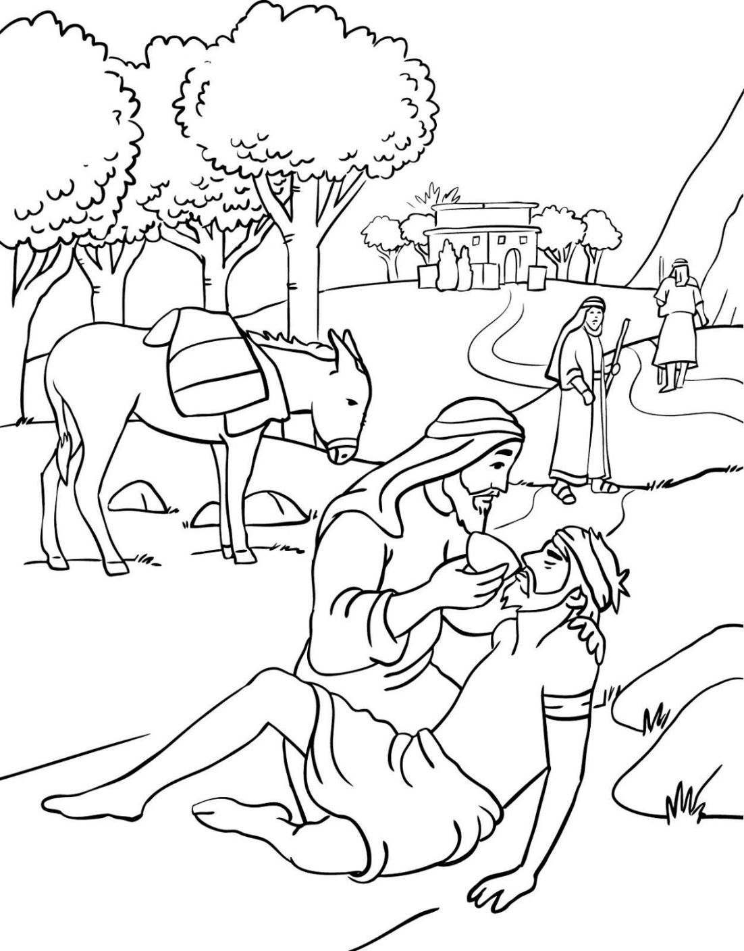

**Cambridge Causeway**

Summer 2023

Bible Study notes

**The Sermon on the Mount**

**2. Helping others**

By Chrissy Cole