**Mary Magdalene**

**Reading:** John 20: 10, 14-18

Mary stood outside the tomb, crying. She turned around and saw Jesus standing there. But she did not know it was Jesus.

He asked her, “Woman, why are you crying? Who are you looking for?”

She thought that this was the gardener. So she said to him, “Did you take him away, sir? Tell me where you put him. I will go and get him.”

Jesus said to her, “Mary.”

She turned toward him and said, “Teacher.”

Jesus said to her, “Go to my followers and tell them this: ‘I am going back to my Father and your Father’”

Mary Magdalene went to the followers and told them, “I have seen the Lord!” And she told them what he had said to her.

**Thought about the reading**

Mary Magdalene was very sad. She had seen her friend Jesus die on a cross. She had seen his body put in a tomb and a big stone rolled over the entrance. Now she has come to put special perfume on his body. She stands by the tomb, but the stone has been rolled away! She wonders where his body has gone.

Jesus stands beside her, but she is crying so much, she thinks he is the gardener. But when Jesus says her name, she knows who it is! Jesus is no longer dead! He is alive again!

She is so happy; she runs to tell the disciples what she has seen with her own eyes. She is the first eyewitness.

**Prayer**

Lord Jesus, thank you that you are alive. Thank you that we know that is true because of the stories of eyewitnesses who saw you with their own eyes. Thank you for the story of Mary Magdalene who saw you in the garden.

Amen

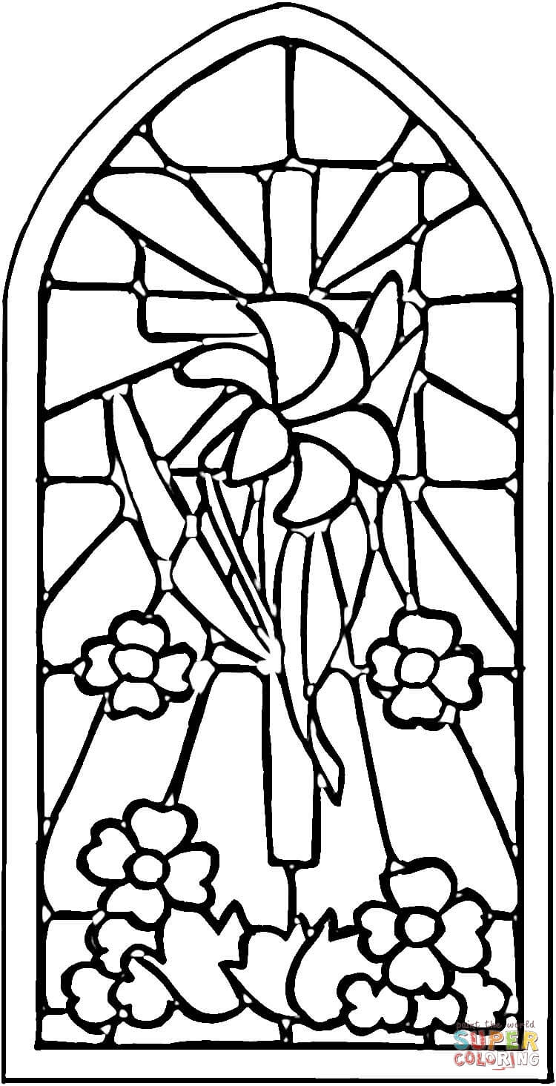

**Cambridge Causeway**

Summer 2021

Bible Study notes

**Eyewitnesses**

**2. Mary Magdalene**

By Chrissy Cole