**Paul**

**Reading: from Acts 22:1-16**

Then Paul said, “I am a Jew. I was born in Tarsus in Cicilia, but I grew up here in Jerusalem. I hurt the followers of the Way of Jesus. I sent many of them to their death. I arrested men and women. I threw them in prison. I even went to Damascus to bring these people as prisoners to Jerusalem to be punished.

I had almost reached Damascus. About noon a bright light from heaven suddenly flashed around me. I fell to the ground and heard a voice speak to me. ‘Paul, Paul!’ it said. ‘Why are you opposing me?’

‘Who are you, Lord?’ I asked.

‘I am Jesus of Nazareth,’ he replied. ‘I am the one you are opposing.’

‘What should I do, Lord?’ I asked.

‘Get up,’ the Lord said. Go into Damascus. There you will be told everything you have been given to do.’ The brightness of the light had blinded me. So my companions led me by the hand into Damascus.

A man named Ananias came to see me. He was a godly Jew who obeyed the Law. He stood beside me and said, ‘Brother Saul, receive your sight!’ At that very moment I was able to see him.

Then he said, ‘The God of our people has chosen you. Now you will tell everyone about what you have seen and heard. So what are you waiting for? Get up and call on his name. Be baptised. Have your sins washed away.’”

**Thought about the reading**

Paul lived shortly after Jesus had gone back to heaven. He hated Christians and did everything he could to stop them following Jesus.

Then one day, when he was travelling to Damascus, he met Jesus on the road. Jesus called him to follow him and to tell people about him all over the Roman empire. Paul was changed when he met Jesus. He knew that he had done wrong, and he asked Jesus to forgive him. Paul went on to start lots of new churches.

It does not matter what we have done in the past. If we tell Jesus we are sorry, he will forgive us. He will change us and help us to follow him, just like he changed Paul.

**Prayer**

Dear Jesus, thank you that you changed Paul from someone who hated Christians to someone who helped to build your church.

Please forgive me for the things I have done wrong. Please change me and help me to follow you.

Amen

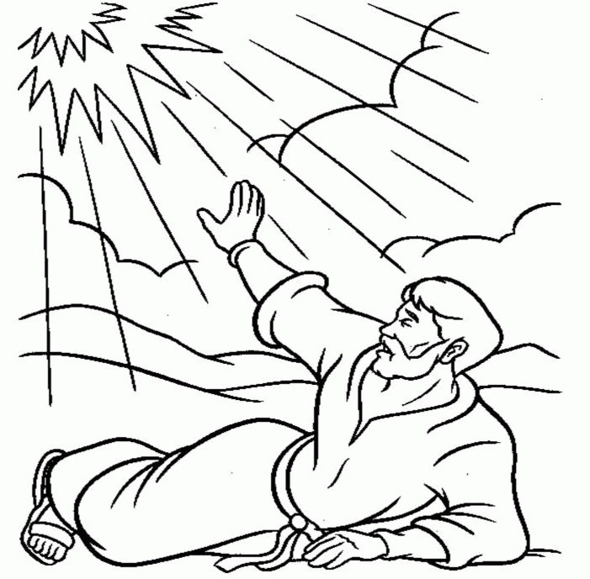

**Cambridge Causeway**

Spring 2025

Bible Study notes

**People changed by Jesus**

**2. Paul**

By Chrissy Cole