Renew
Reading: Nehemiah 2:1-4, 8b
In the 20th year of King Artaxerxes, some wine was brought to the king. I had never before been sad when I was with him, but now I was sad. So the king asked me, “Are you sick? Why do you look so sad? I think your heart is full of sadness.”
Then I was very afraid. But even though I was afraid, I said to the king, “May the king live forever! I am sad because the city where my ancestors are buried lies in ruins, and the gates of that city have been destroyed by fire.”
Then the king said to me, “What do you want me to do?”
Before I answered, I prayed to the God of Heaven.
The king gave me everything I asked for. The king did that because God was kind to me.
Thought about the reading
Nehemiah was very sad when he heard that the walls of Jerusalem were broken down and the gates burnt. He spent several days praying and asking God for help.
He was sad when he went to work, giving King Artaxerxes his wine. The king noticed how sad he was. The king might have been angry with him, but God helped Nehemiah. The king wanted to know why Nehemiah was sad and asked what he could do to help. Nehemiah asked if he could go to Jerusalem to rebuild the walls and the king said ‘Yes.’ He also gave him the wood he would need for the job and some soldiers to protect him on the journey.
Sometimes things happen that make us feel sad, like Nehemiah. We can always tell God when that happens, and God will help us. He will show us what to do. He may send other people to help us.
Prayer
Lord Jesus, when things make us sad, please help us to tell you.
Thank you that hear us, and you will help us. Thank you for the people that you send to help us.
Amen
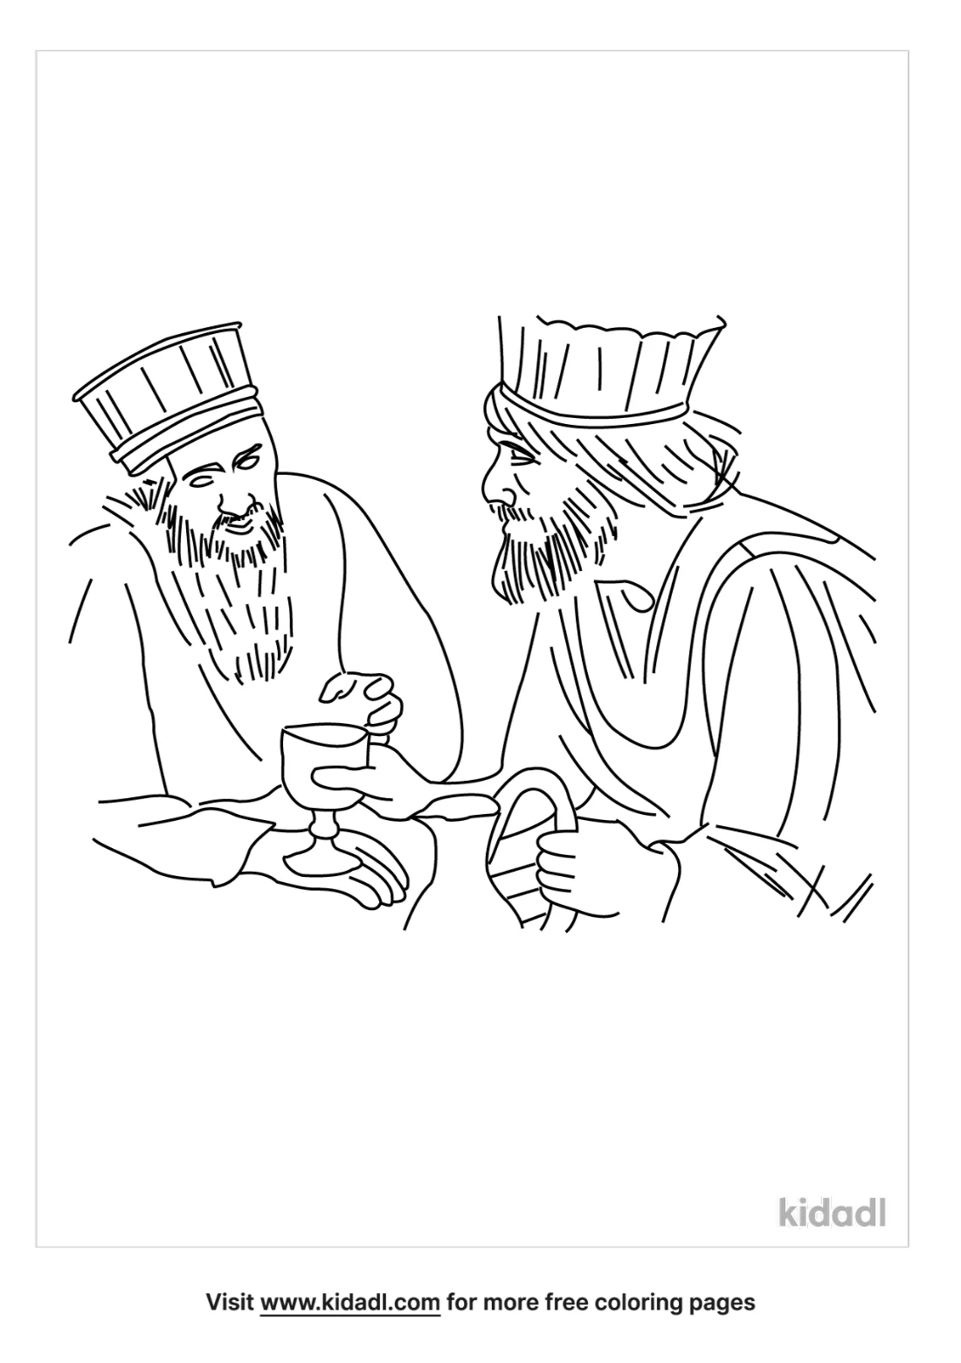

Cambridge Causeway

Autumn 2022
Bible Study notes

Nehemiah’s Story
2.Renew
By Chrissy Cole

