Ruth: trusting God when we don’t understand
Reading: Ruth 1:15-18
“Look,” said Naomi. “Your sister-in-law is going back to her people and her gods. Go back with her.”
But Ruth replied, “Don’t try to make me leave you and go back. Where you go I’ll go. Where you stay I’ll stay. Your people will be my people. Your God will be my God. Where you die I’ll die. And there my body will be buried. I won’t let even death separate you from me. If I do, may the Lord punish me greatly.” Naomi realized that Ruth had made up her mind to go with her. So she stopped trying to make her go back.
Thinking about the reading
When Naomi decided to go back to Bethlehem, she told her daughters-in-law to go home to their own families. Ruth refused. She wanted to stay with Naomi. She knew that Naomi would need someone to help her. She was a faithful friend. She left her home, went with Naomi on the long journey to Bethlehem, to a place she did not know. She loved Naomi and was faithful to her. When we choose to follow Jesus, he wants us to be faithful to him and to love him because he loves us and died for us.
Ruth said that Naomi’s people would be her people. The Church is God’s people, so they are our people too, like one big family, people who love and care for each other like Ruth and Naomi did.
Ruth said that Naomi’s God was her God. That means being faithful to God, even when things are difficult, just as Ruth was faithful. Jesus told his followers that they would have troubles – difficult times, sad times. But that doesn’t mean he has forgotten us. He too is faithful and he promised he would never leave us. So don’t give up but keep on trusting him whatever happens.

Prayer
Lord Jesus, you are my faithful God. Please help me to follow you always and not to worry even though I don’t know what will happen next. Help me to trust you and be faithful to you.
Amen.

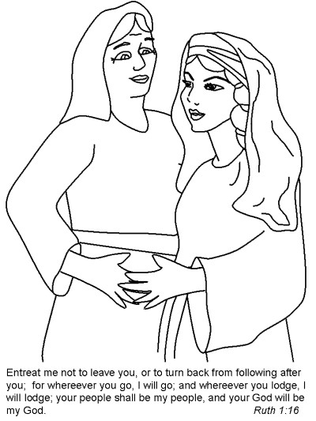

Cambridge Causeway

Summer 2026
Bible Study notes

The Story of Ruth
2. Ruth – trusting God when we don’t understand.
Based on the teaching plan published by Count Everyone In.

