**3. Ascension**

**Reading:** Acts 1:9-11

After Jesus said this, he was lifted up into the sky. While they were watching, he went into a cloud, and they could not see him. They were staring into the sky where he had gone. Suddenly two men wearing white clothes were standing beside them. They said, “Men of Galilee, why are you standing here looking into the sky? You saw Jesus carried away from you into heaven. He will come back in the same way you saw him go.”

**Thought about the reading**

After Jesus was raised from the dead, he appeared to many of his followers. Then one day when they were all together, they saw him lifted up to heaven. We remember this on Ascension Day.

Jesus died on the cross, but God brought him back to life. He did not die again, but God took him back to heaven while he was still alive. His followers saw this happen. They were eyewitnesses.

They saw two angels. Angels are God’s messengers. These angels brought a message from God. They said that one day, Jesus will return from heaven.

Today we can be sure that Jesus is alive. He is alive in heaven. He prays to the Father for us. He sends his Holy Spirit to us to help us to follow him.

One day he will come back from heaven and put right everything that is wrong in our world. He will make our world like new.

**Prayer**

Lord Jesus, we know that you are alive in heaven. Thank you that you pray for us.

Thank you that you send us your Holy Spirit. Please send your Holy Spirit now to help us as we follow you.

When things are hard for us, help us to remember that one day you will return and make everything right.

Amen

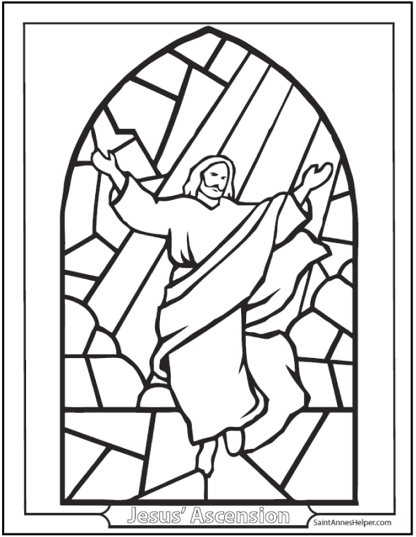

**Cambridge Causeway**

Summer 2021

Bible Study notes

**Eyewitnesses**

**3. Ascension**

By Chrissy Cole