**Moses**

**Reading:** Exodus 14:5, 8, 10, 13, 21-23, 27

Pharaoh received a report that the Israelites had escaped. When he heard this, he and his officials changed their minds about what they had done. And Pharaoh chased the Israelites.

When the Israelites saw Pharoah and his army coming towards them, they were very, very frightened and cried to the Lord for help.

Moses answered, “Don’t be afraid! Don’t run away! Stand where you are and watch the Lord save you today. You will not have to do anything but stay calm. The Lord will do the fighting for you.”

Moses raised his hand over the Red Sea, and the Lord caused a strong wind to blow from the east. The wind blew all night long. The sea split, and the wind made the ground dry. The Israelites went through the sea on dry land. Then all of Pharoah’s chariots and horse soldiers followed them into the sea. Just before daylight, Moses raised his hand over the sea. And the water rushed back to its proper level. The Egyptians were running as fast as they could from the water, but the Lord swept them away with the sea.

**Thought about the reading**

Moses lived a long time ago. many years before Jesus. When he was born, the people of Israel lived in Egypt where they worked as slaves. They built lots of important buildings for the King of Egypt, Pharaoh.

They cried to God for help, and he heard them. He sent Moses to lead them out of Egypt. But Pharoah did not want them to go. He chased them with his army. When the people of Israel reached the sea, God parted the sea so that they could walk across to the other side. When the Egyptians tried to follow, they were washed away in the sea.

God used Moses to rescue his people and to save them from the Egyptian army. But sometimes Moses did not feel good enough to lead the people. He felt that he was weak and not very good at speaking. God gave him the strength he needed.

Even when we feel weak, God can give us strength if we trust him. He can use us to help other people.

**Prayer**

Lord Jesus, thank you for Moses. Thank you that although he felt weak, you gave him strength to lead your people out of Egypt.

When I feel weak, please give me strength to follow you. Amen

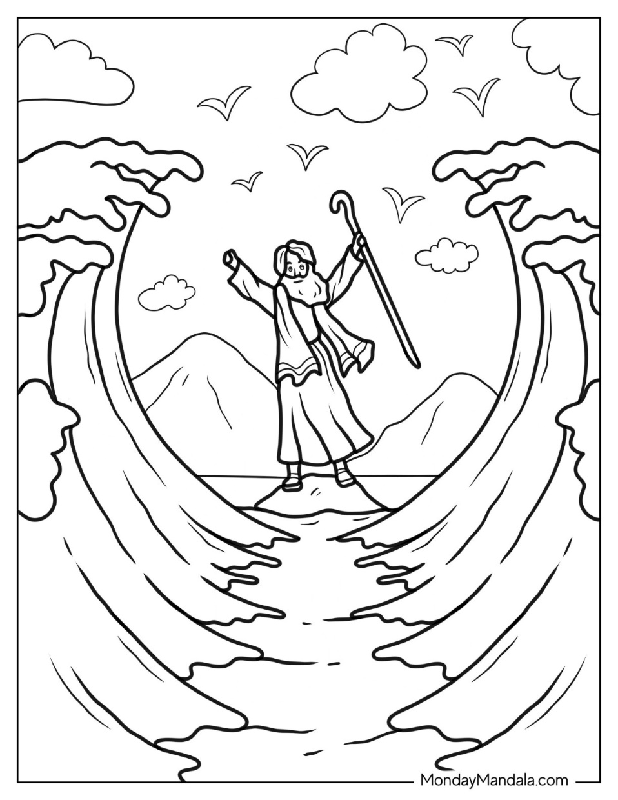

**Moses**

**Cambridge Causeway**

Spring 2024

Bible Study notes

**Heroes of the Bible**

**3. Moses**

By Chrissy Cole

Trust the Lord always, because in the Lord you have a place of safety forever.

Isaiah 26:4