Restore
Reading: Nehemiah 2:17-18, 3:1-3
I said to them, ”You can see the trouble we have here: Jerusalem is a pile of ruins, and its gates have been burned with fire. Come let’s rebuild the wall of Jerusalem. Then we will not be ashamed anymore.”
I also told them that God had been kind to me. I told them what the king had said to me. Then they answered, “Let’s start to work, now!” So we began this good work.
The name of the high priest was Eliashib. He and his brother the priests went to work and built the Sheep Gate. They prayed and made that gate holy to the Lord. They set its doors in place in the wall. The priests worked on the wall as far as the Tower of the Hundred and the Tower of Hananel. They prayed and made their work holy to the Lord.
The men from Jericho built the wall next to the priests. And Zaccur built the wall next to the men of Jericho.
The sons of a man named Hassenaah built the Fish Gate. They set the beams in place, they put doors on the building. Then they put the locks and bolts on the doors.
Thought about the reading
When Nehemiah arrived in Jerusalem, he rode round the outside of the city to see what needed to be done. Then he called the people living there to help him rebuild them. Chapter 3 is a long list of people who helped to build the wall. Each person or family had their own bit to rebuild. The job seemed to be very big, but when everyone worked together, they were able to get it done.

God is also building. He is building his Kingdom. He has called us to help him. Each one of us has our own part in the work. Every day, wherever we are, we are helping to build his Kingdom. We do this by being kind to the people that we meet and loving them as God loves them.

Prayer
Lord Jesus, thank you that you have called us to help you build your Kingdom.
Please help us to work together as you want us to.
Amen
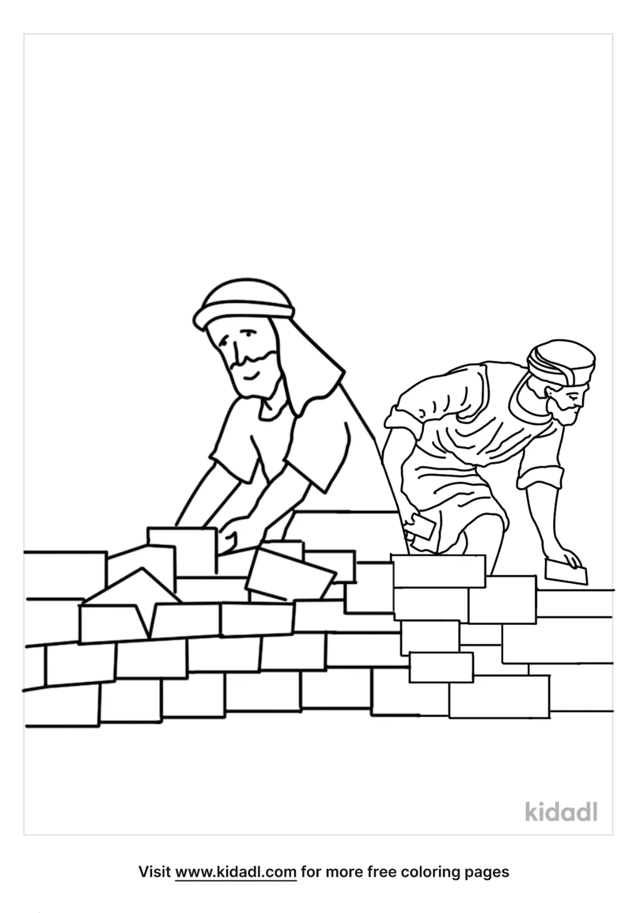

Cambridge Causeway

Autumn 2022
Bible Study notes

Nehemiah’s Story
3. Restore
By Chrissy Cole

