**Esther**

**Reading: from Esther chapters 3 and 4**

Haman came to King Xerxes and said, “King Xerxes, there is a certain group of people scattered among the people in all the provinces of your kingdom. They keep themselves separate from other people. Their customs are different and they don’t obey the king’s laws. It is not right for the king to allow them to continue to live in your kingdom. If it pleases the king, I have a suggestion: give a command to destroy these people.”

Then the king said to Haman, “Do what you want with them.”

When Mordecai (Esther’s cousin), heard about all that had been done, he went out into the city crying loudly. Esther sent a servant to find out what was bothering Mordecai and why. Mordecai told the servant everything. He wanted Esther to go to the king and beg him for mercy for Mordecai and her people.

He said, “Who knows, maybe you have been chosen to be queen for such a time as this.”

**Thought about the reading**

Esther lived a long time ago, many years before Jesus was born. Her people, the people of Israel, had been carried away from their home to live in a foreign land.

Esther was an ordinary girl, but she was chosen by King Xerxes, King of Persia, to be his queen.

Haman worked for King Xerxes. He hated Mordecai and the people of Israel and wanted to kill them. The king agreed to let him do this. Esther was the only one who could save them. She went to the king and asked him to stop it happening and he agreed. Haman was punished instead.

Esther probably did not think she was anyone special, but God loved her and had a plan for her life. God’s plan was for Esther to become queen so that she could save her people. He helped her to be brave when she went to the king.

God loves you, just like he loved Esther, and he has a plan for your life. He has something for you to do which only you can do, and he will help you to do it.

**Prayer**

Lord Jesus, thank you for Esther. Thank you that you made her brave so that she could go to the king and save her people.

Please show me what you want me to do, and help me to be brave to do it. Amen

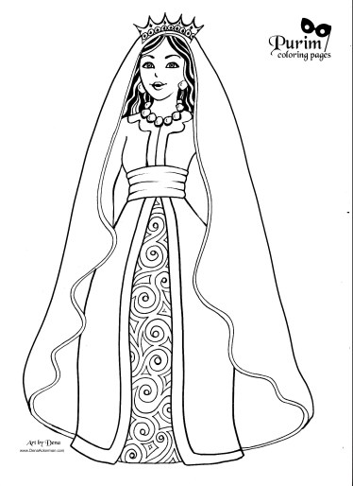

**Esther**

**Cambridge Causeway**

Spring 2024

Bible Study notes

**Heroes of the Bible**

**4. Esther**

By Chrissy Cole

Trust the Lord always, because in the Lord you have a place of safety forever.

Isaiah 26:4