Facing Opposition
Reading: Nehemiah 4:
When Sanballat heard that we were building the wall of Jerusalem, he was very angry and upset. He started making fun of the Jews. Sanballat talked with his friends and the army at Samaria and said, “What are these weak Jews doing? Do they think we will leave them alone? What do these Jews think they are building? If even a small fox climbed up on it, he would break down their wall of stones!”
Nehemiah prayed.
Sanballat and his friends heard that the people continued working on the walls of Jerusalem. They heard the people were repairing the holes in the wall. So all these men got together and made plans against Jerusalem. They planned to stir up trouble against Jerusalem. They planned to come and fight against the city. But we prayed to our God. And we put guards on the walls to watch day and night so that we could be ready to meet them.

Thought about the reading
Sanballat and his friends were not part of God’s people. They were enemies of the Jews. They did not want the Jews to rebuild the walls of Jerusalem. First, they tried to stop them by making fun of them. When that did not work, they decided they would attack the city.
When they faced opposition, Nehemiah and the Jews prayed to God for help. Then they prepared to defend the city. They knew that God would help them.
Sometimes we may face opposition. People may make fun of us and laugh at us because we believe in Jesus, and we are following him. When that happens, we can pray to Jesus and ask him to help us. We know that he will hear our prayer.
Prayer
Lord Jesus, please help us when we face opposition, when people laugh at us or make fun of us because we are following you.
Please fill us with your Holy Spirit and give us strength to keep following you.
Amen
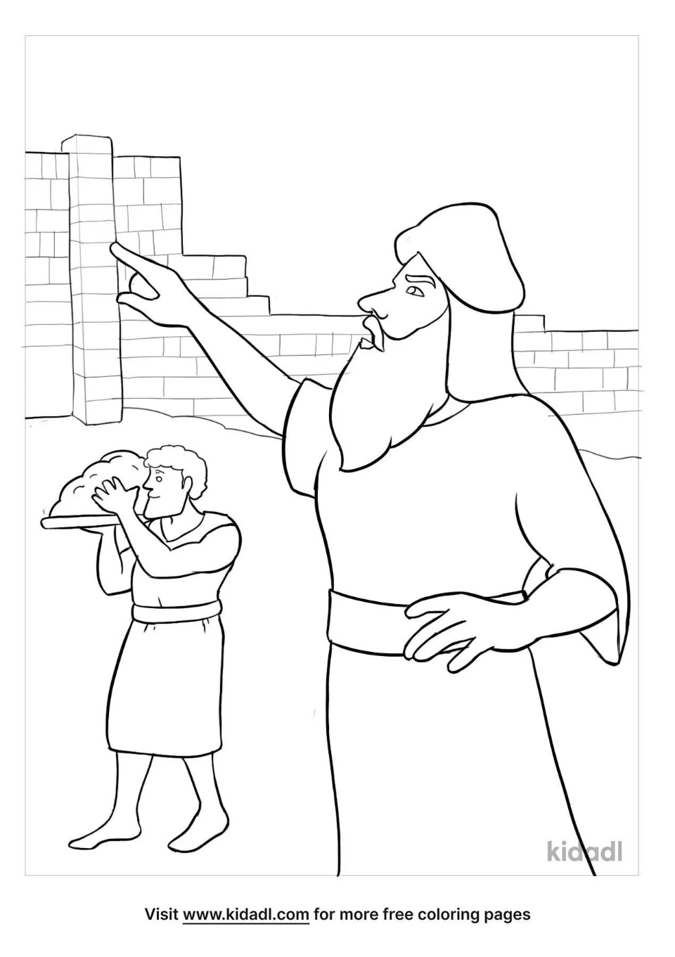 Sanballat makes fun of the Jews rebuilding the walls of Jerusalem.

Cambridge Causeway

Autumn 2022
Bible Study notes

Nehemiah’s Story
4. Facing Opposition
By Chrissy Cole

