**Loved!**

**Reading: from Luke 15:11-20**

Jesus said, “There was a man who had two sons. The younger son spoke to his father. He said, ‘Father, give me my share of the family property.’ So the Father divided his property between the two sons.

Not long after that, the younger son packed up all he had. Then he left for a country far away. There he wasted his money on wild living. He spent everything he had. Then the whole country ran low on food. So the son didn’t have what he needed.

Then he began to think clearly again. He said, ‘How many of my father’s hired servants have more than enough food! But here I am dying of hunger! I will get up and go back to me father. I will say to him, “Father, I have sinned against heaven. I have sinned against you. I am not longer fit to be called your son. Make me like one of your hired servants.” So he got up and went to his father.

While his son was still a long way off, his father saw him. He was filled with tender love for his son. He ran to him. He threw his arms around him and kissed him.”

**Thought about the reading**

Love is very important. Everyone needs to feel loved. If we feel loved, then we feel safe and happy. If we do not feel loved, then we feel sad and frightened.

In the reading, Jesus tells a story to show us how much God loves us. God is like the father, who loves his son even when he runs away and does bad things. We do not have to make ourselves into better people so that God will love us. He loves us even before we are good enough.

When the son comes home, the father has a big party. He does not make his son into a servant, even though maybe that is what he deserves. He welcomes him back into his family. Like the father, God gives us more than we deserve. He wants us to be one of his family. He sent Jesus to die for us so that we could be become children of God.

The son is safe again and has everything he needs. When God loves us, we know that we too are safe, and he is looking after us. God’s love will never end.

**Prayer**

Dear Father in heaven, thank you that you love us even when we don’t deserve it. Thank you that you want us to be part of your family. Thank you that your love never ends.

Please help me to love you.

Amen

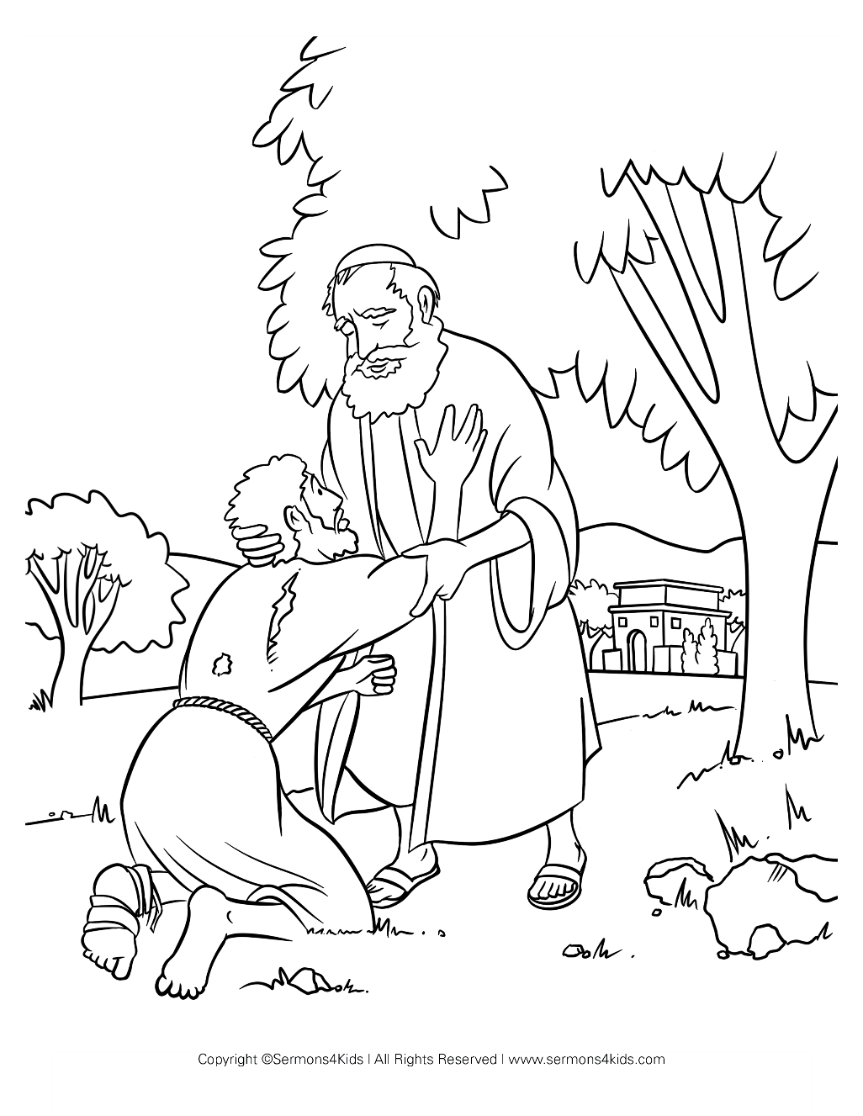

**Cambridge Causeway**

Autumn 2024

Bible Study notes

**What Jesus has done for me**

**4. Loved!**

By Chrissy Cole