A New Commandment
Readings: John 11:25-26
Jesus said, ‘I am the resurrection. I am life. Everyone who believes in me will have life, even if they die. And everyone who lives and believes in me will never really die.’

Thought about the readings
The reading today comes from a longer story which tells how Jesus brought someone called Lazarus to life after he had died. The word resurrection means coming back to life after death.
We know that on Easter Sunday Jesus came back to life after he had died on the cross. He gives life to everyone who decides to follow him. When we die, if we believe in Jesus, he will give us life in heaven with him which will never end.
Jesus also gives us new life today. Sometimes we say someone starts a new life when they move to a new place or start a new job. When we decide to follow Jesus, he gives us a new life. We don’t have to move! In our old life, we lived for ourselves and did what we wanted. In our new life, we live for Jesus and we want to do what he says. He gives us his Spirit who helps us to be like a new person.

Prayer
Lord Jesus, thank you that you came back to life on Easter Sunday. Because you are alive today, you give new life to everyone who believes in you.
Lord Jesus, I believe in you. I am sorry for all the things I have done wrong. Please fill me with your Spirit and give me new life today.
Amen

The picture for colouring shows the place where Jesus was buried. It was like a cave with a big stone across the entrance. On Easter Sunday morning, the stone was rolled away and the cave was empty because Jesus was alive!

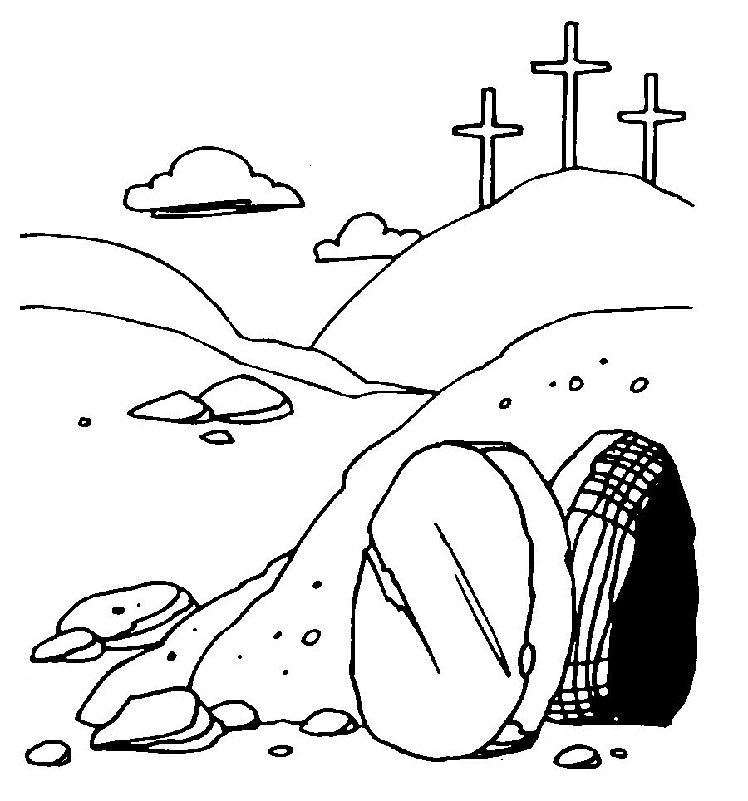

Cambridge Causeway

Spring 2021
Bible Study notes

All Things New:
New life
By Chrissy Cole

