4. Pentecost
Reading: Acts 1:7-8
Jesus said, “The Holy Spirit will come on you and give you power. You will be my witnesses. You will tell people everywhere about me – in Jerusalem, in the rest of Judea, in Samaria, and in every part of the world.”
Acts 2:1-4
When the day of Pentecost came, they were all together in one place. Suddenly a noise came from heaven. It sounded like a strong wind blowing. This noise filled the whole house where they were sitting. They saw something that looked like flames of fire. The flames were separated and stood over each person there. They were all filled with the Holy Spirit, and they began to speak different languages. The Holy Spirit was giving them the power to do this.

Thought about the reading
Before Jesus went up to heaven, he told the disciples they were to be his witnesses. They were to tell everyone about what they had seen him do, what he taught them and how he was raised from the dead. Jesus said he would send the Holy Spirit to give them power to be good witnesses.
Pentecost is a Jewish celebration like harvest, when they thank God for the food they have grown. Jesus’ friends were together for this celebration, when God sent the Holy Spirit, just like Jesus promised. They started speaking different languages. The Spirit gave them power to do this so that they could be witnesses to people from all over the world.
Jesus sends his Holy Spirit to us too, to give us power, so that we can be witnesses for him.

Prayer
Lord Jesus, thank you that you promised to send your Holy Spirit to everyone who follows you.
Please send your Holy Spirit to me. Please give me power so that I can be a witness and tell people about you.
Amen
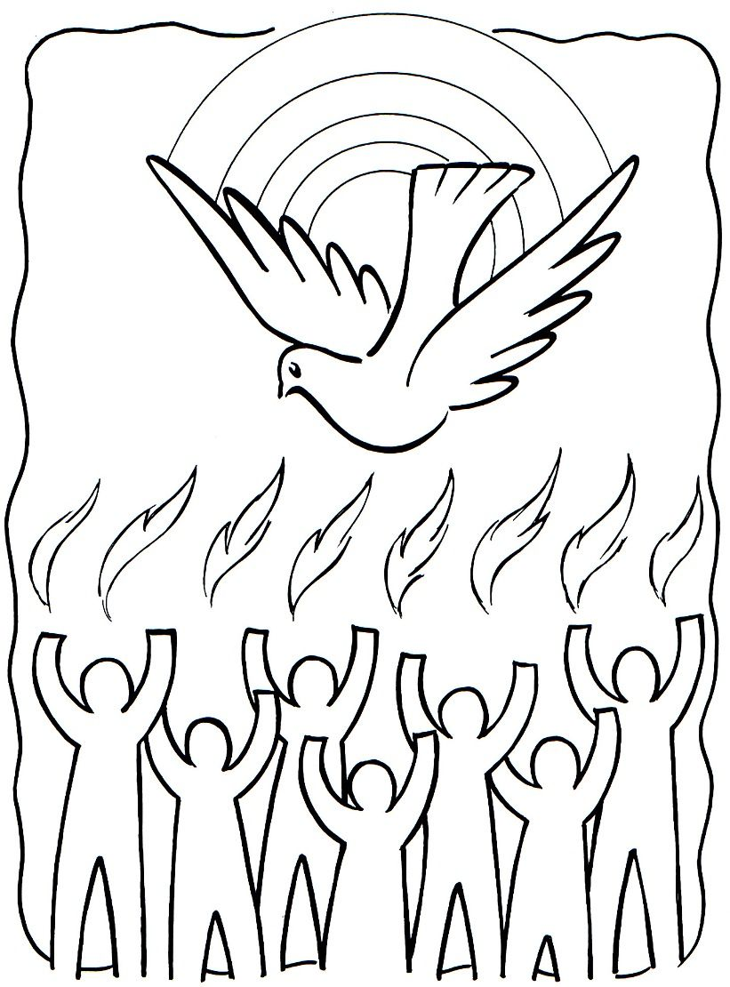

Cambridge Causeway

Summer 2021
Bible Study notes

Eyewitnesses
4. Pentecost
By Chrissy Cole

