**Daniel’s friends**

**Reading: From Daniel chapter 3**

King Nebuchadnezzar had a gold idol made. He said, “Whoever does not bow down and worship this gold idol will be thrown into a very hot furnace.”

Then some of the Chaldeans said to the King, “King, may you live forever! There are some Judeans that ignored your order. They didn’t bow down to worship the gold idol you set up. They are called Shadrach, Meshach and Abednego.”

The king became very angry. He called for Shadrach, Meshach and Abednego and said, “If you don’t worship the idol, you will be thrown into the hot furnace Then no god will be able to save you!”

They answered, “The God we serve can save us. And, if he wants to, he can save us from your power. But even if he does not save us, we refuse to serve your gods.”

The king told the soldiers to throw Shadrach, Meshach and Abednego into the hot furnace.

So they were tied up and thrown into the hot furnace.

The king jumped to his feet and said, “Look! I see four men walking around in the fire. They are not tied up and they are not burned. The fourth man looks like an angel.”

Shadrach, Meshach and Abednego came out of the fire. Everyone could see that the fire had not burned them!

**Thought about the reading**

Shadrach, Meshach and Abednego were friends of Daniel. Like Daniel, they belonged to the people of Israel and worshiped God Almighty. When the king said that everyone must worship the gold idol, they refused, because they knew they should worship only God. This was the right thing to do, but they knew they would be thrown into the hot furnace.

Sometimes, we have too have to make a choice. We can choose to do the right thing, or we can choose to do something wrong. It may be difficult to do the right thing. It may get us into trouble with other people. God helped Daniel’s friends to do the right thing, and he will help us too.

**Prayer**

Dear Jesus, please help us to choose to do the right thing, even when it is difficult.

Amen

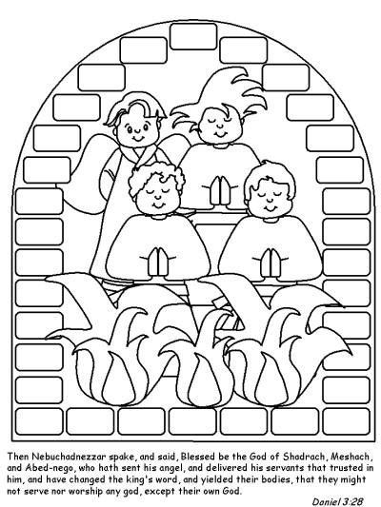

**Daniel’s friends**

**Cambridge Causeway**

Summer 2024

Bible Study notes

**Heroes of the Bible Part 2**

**5. Daniel’s friends**

By Chrissy Cole