**David**

**Reading from 1 Samuel 17**

The Philistines had a champion fighter named Goliath. He was over 9 feet tall! He came out every morning and evening and stood before the Israelite army. He insulted Israel like this for 40 days.

David said to Saul (the king), “People shouldn’t let Goliath discourage them. I am your servant. I will fight against this Philistine.”

David said to the Philistine, “You come to me using sword, spear and javelin. But I come to you in the name of the Lord Almighty, the God of the armies of Israel. Today the Lord will let me defeat you. The battle belongs to the Lord, and he will help us defeat all of you.”

Goliath started to attack David. He slowly walked closer and closer to David, but David ran out to meet him.

David took a stone out of his bag. He put it in his sling and swung the sling. The stone flew from the sling and hit Goliath right between the eyes. The stone sank deep into his head, and Goliath fell to the ground – face down.

So David defeated the Philistine with only a sling and one stone!

**Thought about the reading**

David lived a long time ago, many years before Jesus was born. When he was a boy, he looked after his father’s sheep. At this time, the Philistines wanted to kill the Israelites and take their land. They had a champion fighter, Goliath, who was like a giant. Everyone was frightened of him, and no-one wanted to fight him.

David was only a boy, but he knew that God was on his side and would help him. He trusted God, and God helped him to kill the giant with just a sling and one stone.

Sometimes things happen to us or around us that seem as frightening as a giant. But if we trust God, he can help us just like he helped David.

**Prayer**

Lord Jesus, thank you for David. Thank you that even though he was just a boy, you helped him to kill the giant.

Please help me to trust you when things are frightening, just like David trusted you. Help me to believe that you are on my side, and you can help me. Amen

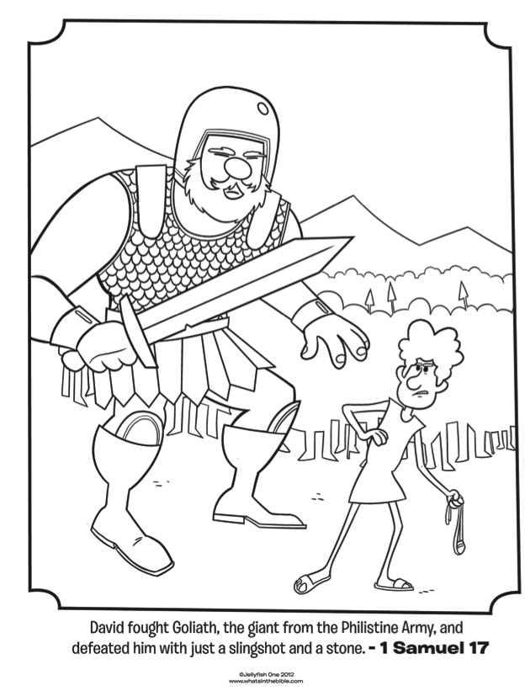

**David**

**Cambridge Causeway**

Spring 2024

Bible Study notes

**Heroes of the Bible**

**5. David**

By Chrissy Cole

Trust the Lord always, because in the Lord you have a place of safety forever.

Isaiah 26:4