**Don’t worry!**

**Reading:** Matthew 6:25-27, 33-34

Jesus said, “Don’t worry. Don’t worry about your life and what you will eat or drink. And don’t worry about your body and what you will wear. Isn’t there more to life than eating? Aren’t there more important things for the body than clothes? Look at the birds of the air. They don’t plant of gather crops. They don’t put away crops in storerooms. But your Father who is in heaven feeds them. Aren’t you worth much more than they are? Can you add even one hour to your life by worrying?

But put God’s kingdom first. Do what he wants you to do. Then all those things will also be given to you. So don’t worry about tomorrow. Tomorrow will worry about itself. Each day has enough worry of its own.”

**Thought about the reading**

What are the things you worry about? Do you worry about the price of food going up? Or the news you see on the television? Perhaps you worry about other people, about your friends and family? Maybe you are worried about being ill.

Everybody worries sometimes, but Jesus said we don’t need to be worried, because our Father in heaven is looking after us. How can we be sure? Jesus said that we should look at the birds. Our Father looks after them and makes sure they have enough to eat, even though they don’t do any work. We are more important than the birds, so he will be sure to look after us too. We can tell Jesus about our worries, and he will help us.

Jesus said that we should put his kingdom first. We should put God’s work before everything else. If we do that, then he will give us all we need.

**Prayer**

Lord Jesus, thank you that you are looking after me and you will make sure that I have everything I need.

Thank you that you understand when I get worried about things. Please help me to remember that I can tell you about my worries. Please help me to put your kingdom first.

Amen

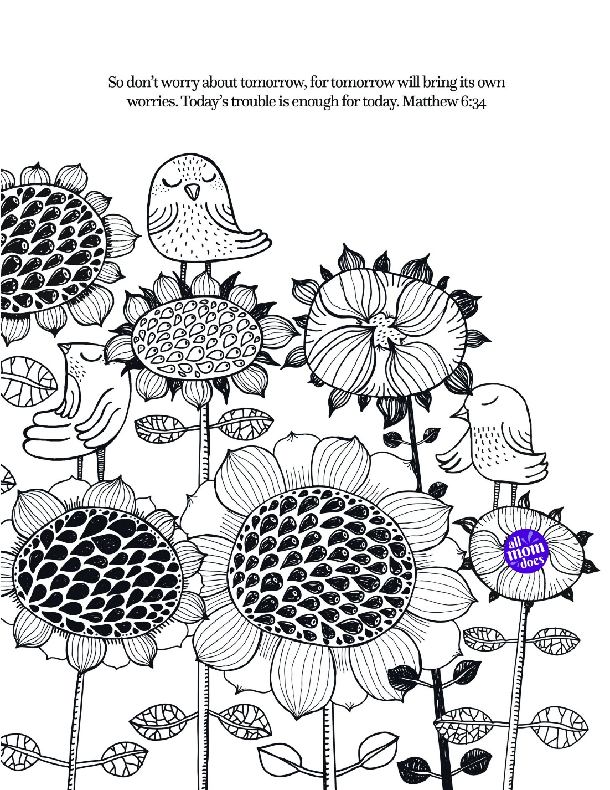

**Cambridge Causeway**

Summer 2023

Bible Study notes

**The Sermon on the Mount**

**5. Don’t worry!**

By Chrissy Cole