**Advent 2**

**Reading:** Revelation 21:1-4

Then I saw a new heaven and a new earth. The first heaven and the first earth had disappeared. Now there was no sea. And I saw the holy city, the new Jerusalem, coming down out of heaven from God. It was prepared like a bride dressed for her husband.

I heard a loud voice from the throne. It said, “Now God’s home is with people. He will live them. They will be his people. God himself will be with them and will be their God. He will wipe away every tear from their eyes. There will be no more death, sadness, crying, or pain. All the old ways are gone.”

**Thought about the reading**

In Advent we get ready for Christmas, and we think about the coming of Jesus as a baby. But we also think about when Jesus will come again. Next time, he will come, not as a baby, but as a king. He will put right everything that is wrong in our world. He will make a new world, where no-one is sad, or in pain.

Sometimes, when we listen to the news or read a newspaper, we can feel sad because the world seems to be full of bad things. The reading today gives us hope that one day things will be better.

We know that Jesus will return because he promised that he would. At the end of the Bible it says, ‘Jesus is the one who says that all of this is true. Now he says, “Yes, I am coming soon.”

Amen! Come, Lord Jesus!’

As we get ready for Christmas, we should also get ready for Jesus’ return. We do that by giving our lives to him and following him.

**Prayer**

Lord Jesus, thank you that you promised that one day you will return and put right everything that is wrong. Please help me to be ready for that wonderful day.

Amen! Come, Lord Jesus!

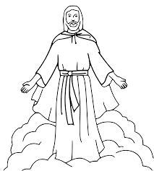

Happy Christmas!

**Cambridge Causeway**

Autumn 2022

Bible Study notes

Advent 2

By Chrissy Cole