**Harvest**

**Reading:** Psalm 65:9-13

You take care of the land.

You water it and make it fertile.

Your streams are always filled with water.

That’s how you make the crops grow.

You pour rain on the ploughed fields;

You soak the fields with water.

You make the ground soft with rain,

And you make the young plants grow.

You start the new years with a good harvest.

You end the year with many crops.

The deserts and hills are covered with grass.

The pastures are covered with sheep.

The valleys are filled with grain.

Everything is singing and shouting for joy.

**Thought about the reading**

Harvest is a special time of year when the farmers bring in all the crops that have been growing in the fields. The crops include wheat, that is made into flour for bread, potatoes, onions, cabbages and carrots. This is also the time of year when we say ‘Thank you’ to God for all the good food he gives us.

In the psalm, we read that it is God that makes the plants grow. The farmer sows the seeds, but God sends the rain and makes the sunshine so that everything grows well.

It is good to thank God that we have good food to eat. Some people do not have enough food. At Harvest time we can remember them by praying for them. We can help them by giving something to a charity that helps them, like a food bank. This is another way of saying ‘Thank you’ to God.

**Prayer**

Father God, thank you for all the good food we have to eat every day. Thank you for sending the rain and sun to make the plants grow.

Please help those today who do not have enough to eat.

Amen

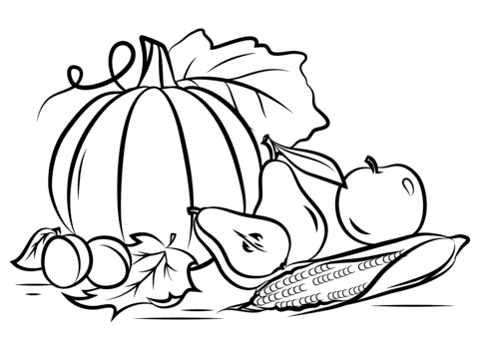

**HARVEST**

**Cambridge Causeway**

Autumn 2021

Bible Study notes

Harvest

By Chrissy Cole